Online Java Editor
Here is an online Java Editor https://www.onlinegdb.com/ that has a debugger that you can use in class if you have Eclipse installed on a computer at home or this weekend until you have Eclipse working.

1. Log into Github first. Then Login to the onlinegdb by clicking Github
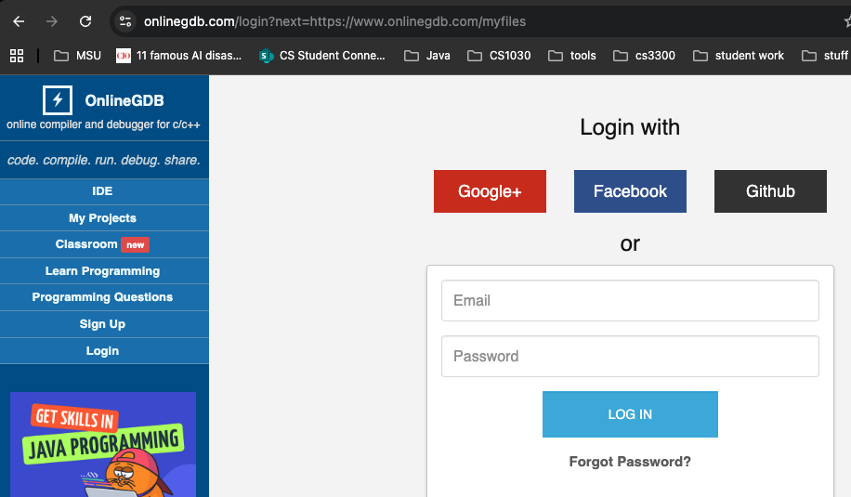
2. Select Java
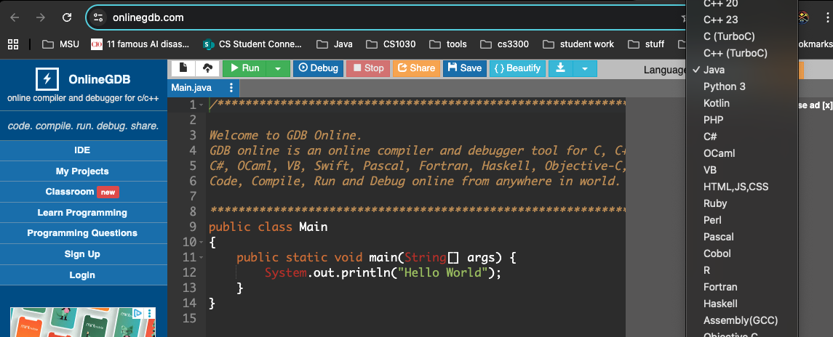

3. Click on My Projects and create new folder
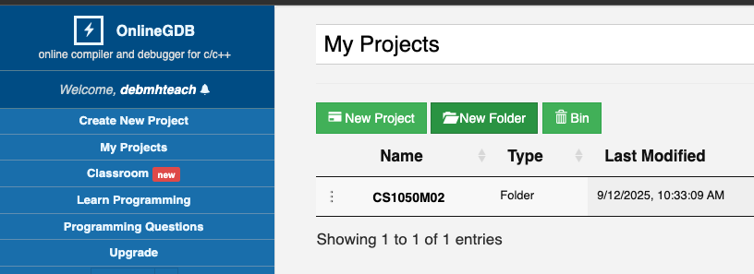

4. I called mine CS150M02


5. Click New Project and the java window opens
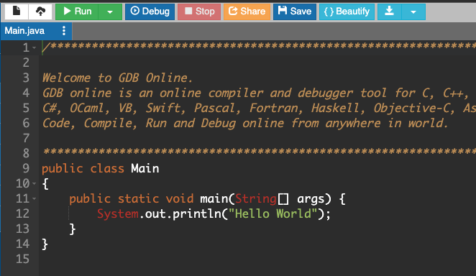

6. Save the project in the folder
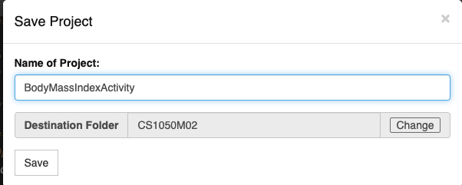

7. You can’t change the class name Main
- Add import java.util.Scanner above main
- Copy code inside main method from BodyMassInexActivity only into the main method created above.
- Run the code and it won’t work until you fix the code
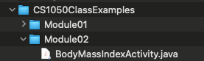
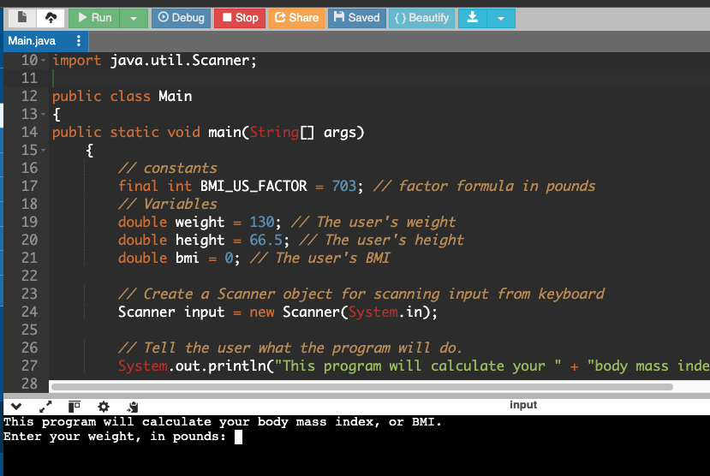

8. Set Break point and click debug.
- Go to bottom and click start to start the debugger
- Click step over
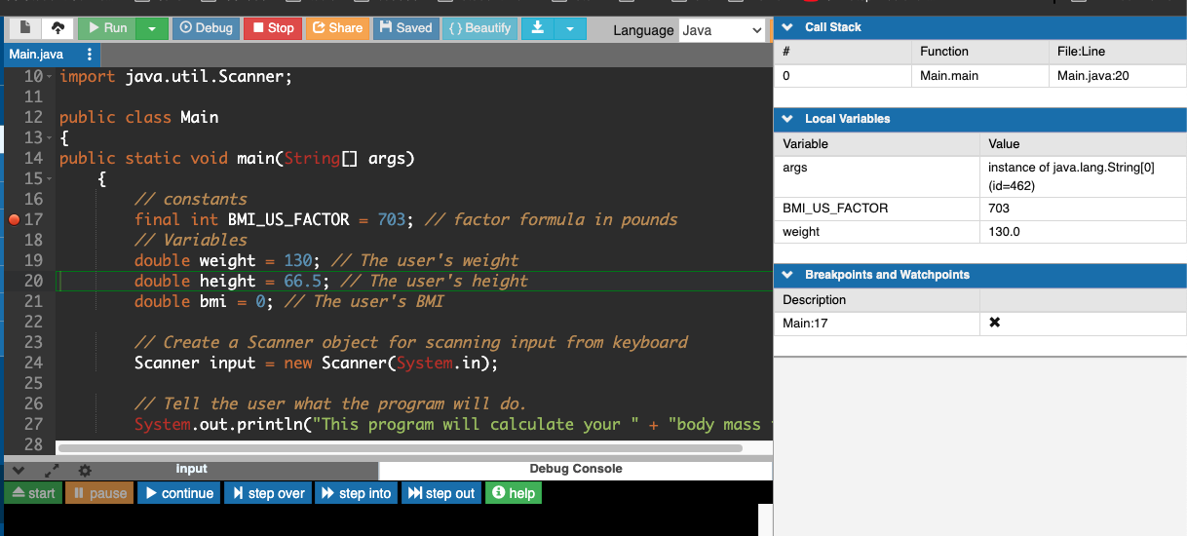

9. Keep saving and the code will be saved for you to put in your Eclipse later.
